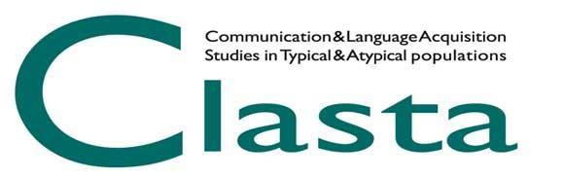

CLASTA AWARD 2023
Best Ph.D. Dissertation

The CLASTA Association is granting one award of 500 euros to the best Ph.D. dissertation (calendar years 2022) focused on issues related to: typical and atypical development of communication and language in their different forms and modalities; the interactions between language development and other developmental domains, the role of individual and environmental factors on communication and language development, design and/or validation of tools for assessing communicative-linguistic skills, language and communication interventions for children with typical and atypical development and evaluation of the effectiveness of interventions.

Doctoral dissertations, relating to Ph.D. courses completed in the calendar year 2022 at a university located in Italy, must be sent in pdf format to giornateclasta@gmail.com by 1st April 2023 (IMPORTANT: in the subject line of the email write: Last name First name_competition_doctoral dissertation).

In addition to the submission of the dissertation, a structured abstract in pdf format (file name: Last name First name_Doctoral dissertation abstract), in which the candidate briefly describes the content of the dissertation, should also be submitted.
The structured abstract should necessarily include the following fields: Title, Theoretical introduction, Objectives and hypotheses, Method (Participants, Procedure, Materials), Results, Discussion, References. The text should not exceed 13,000 characters, spaces included, including references and should be written in Times New Roman font, 12 point size, double spaced. The references should refer exclusively to those listed in the abstract itself. Any tables and/or figures should be inserted at the end of the text and should not exceed one page.
Abstracts exceeding 13,000 characters, spaces included, including the references, will not be considered for the attribution of the award.
Personal data (name, surname, affiliation, doctoral school, supervisor) and telephone number must be included in the e-mail. Personal data should NOT be included in the abstract file.

The Committee in charge of the selection process will be nominated after the deadline for submission of applications and will be composed of three members: one member of the CLASTA Board, two CLASTA members chosen by the Board based on specific expertise and avoiding conflicts of interest (such as supervisor and membership in the same research group and/or department or research institute).
The evaluation of the submitted contributions will be mainly based on the following criteria:
1) Innovative aspects and originality (0-5 points);
2) Methodological appropriateness (0-5 points);
3) Congruence between hypotheses and results (0-5 points);
4) Theoretical and practical implications of the results (0-5 points);
5) Reference suitability (0-5 points).

The evaluation procedure will be divided into two consecutive phases: a first selection of the contributions will be made based on the evaluation of the abstracts and a subsequent final evaluation will be made following a full reading of the selected theses.

To participate, the candidate must have CLASTA membership for the year 2023. It is not possible to participate at the same time in the Best Doctoral Dissertation Award and other awards.
The winner will be notified personally and will be invited to present a summary of her/his work during the CLASTA Conference, in the occasion of the award ceremony on May 19, 2023; the award will be made official on the CLASTA website.

